SQL CLASS - 9

TOPICS – Constraints

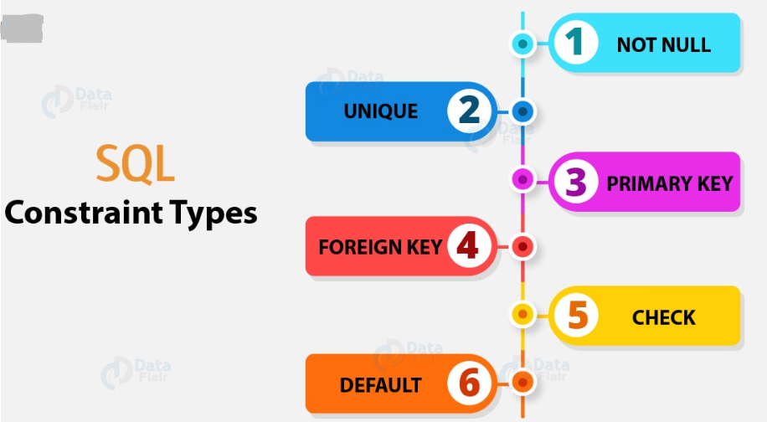

Constraints in SQL -

- Constraints are used to specify rules for data in a table.
- Limit the type of data that can be inserted into a table therefore ensures the data reliability and accuracy in the database.
- Constraints can be a column level or a table level constraints.
- Column level constraints apply to a single column and table-level constraints apply to the entire table.
- Oracle does not support Constraint on Column or attributes whose types USER_DEFINED OBJECT, NESTED TABLE, VARRAY, REF, and LOB.

1. Not Null Constraint
- Not Null Constraint ensures that a column cannot have NULL values means we are not allowed to insert or update with null in a column on which NOT NULL constraint is applied.
- Not Null Constraint cannot be defined at table level. It is column level constraint.
- Can be applied while creating a table or after table is created.
- By default, all columns in a table allow nulls in the absence of a value.

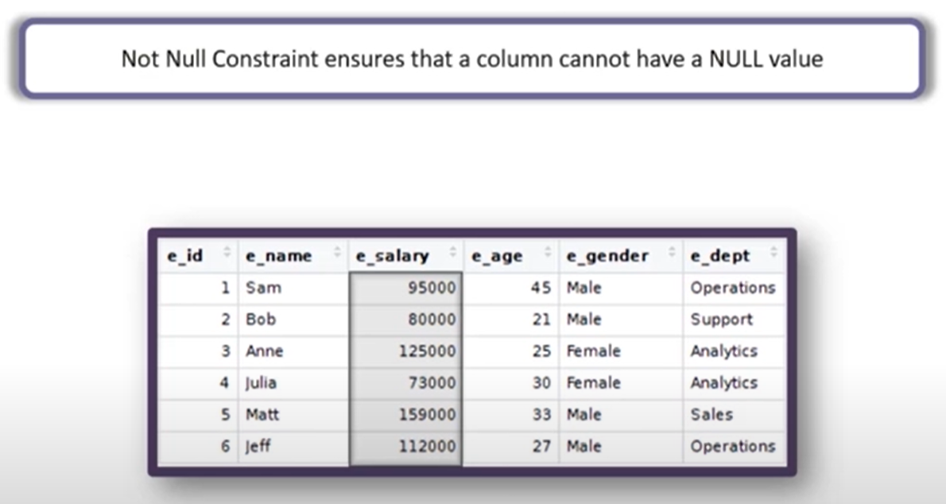

Syntax -
While creating a table

Run -
CREATE TABLE studentsinfo
(
studentid NUMBER NOT NULL,
studentname VARCHAR2(1000),
parentname VARCHAR2(1000),
phonenumber NUMBER
);

INSERT INTO studentsInfo (StudentId, StudentName, ParentName, PhoneNumber)
VALUES (1,'Hari','Prasad', 78787878);

INSERT INTO studentsInfo (StudentId, StudentName, ParentName, PhoneNumber)
VALUES (null,'Hari','Prasad', 78787878);
INSERT INTO studentsInfo ( StudentName, ParentName, PhoneNumber)
VALUES ('Hari','Prasad', 78787878);
UPDATE studentsInfo set StudentId = null where StudentId = 2;
CREATE TABLE studentsInfo
(
StudentId NUMBER NOT NULL,
StudentName VARCHAR2(1000),
ParentName VARCHAR2(1000),
PhoneNumber NUMBER NOT NULL
);
INSERT INTO studentsInfo (StudentId, StudentName, ParentName, PhoneNumber )
VALUES (2,'Hari','Prasad', 78787878);

INSERT INTO studentsInfo (StudentId, StudentName, ParentName, PhoneNumber)
VALUES (null,'Hari','Prasad', 78787878);

INSERT INTO studentsInfo (StudentId, StudentName, ParentName, PhoneNumber)
VALUES (null,'Hari','Prasad', null);

INSERT INTO studentsInfo (StudentId, StudentName, ParentName, PhoneNumber)
VALUES (2,'Hari','Prasad', null);

Syntax -
After Table is created -

CREATE TABLE studentsInfo
(
StudentId NUMBER,
StudentName VARCHAR2(1000),
ParentName VARCHAR2(1000),
PhoneNumber NUMBER
);

ALTER TABLE studentsInfo MODIFY (StudentId NOT NULL);

INSERT INTO studentsInfo (StudentId, StudentName, ParentName, PhoneNumber)
VALUES (null, 'Hari', 'Prasad', 78787878);

ALTER TABLE studentsInfo MODIFY (StudentId NULL);

INSERT INTO studentsInfo (StudentId, StudentName, ParentName, PhoneNumber)
VALUES (null, 'Hari', 'Prasad', 78787878);

ALTER TABLE studentsInfo MODIFY (StudentId NOT NULL);

INSERT INTO studentsInfo (StudentId, StudentName, ParentName, PhoneNumber)
VALUES (null, 'Hari', 'Prasad', 78787878);

2. Unique Constraint

- Unique constraints allow you to ensure that the data stored in a column, or a group of columns, is unique among the rows in a table.
- Unique constraint can be defined at column level as well as at table level.
- For two unique columns, unique constraints at table level can allow values in combination but at column level it should be unique.
- Unique constraint allows null values
- Can be applied while creating a table or after table is created.
- Unique key cannot be implemented on columns having LOB, LONG, LONG RAW, VARRAY, NESTED TABLE, OBJECT, BFILE, REF and TIMESTAMP
- A composite UNIQUE key cannot have more than 32 columns.

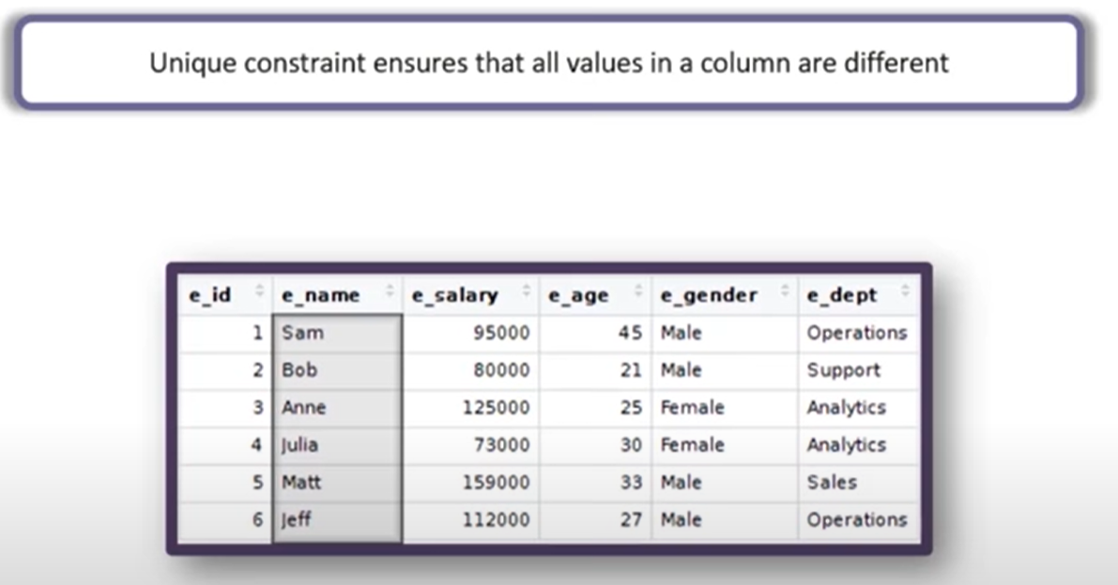

Syntax -
While creating a table (At column level)

Run -
CREATE TABLE studentsinfo
(
studentid NUMBER UNIQUE,
studentname VARCHAR2(1000),
parentname VARCHAR2(1000),
phonenumber NUMBER
);

INSERT INTO studentsInfo (StudentId,StudentName,ParentName,PhoneNumber)
VALUES (1,'Hari','Prasad',78787878);

INSERT INTO studentsInfo (StudentId,StudentName,ParentName,PhoneNumber)
VALUES (1,'Amol','Rao',78787878);

INSERT INTO studentsInfo (StudentId,StudentName,ParentName,PhoneNumber)
VALUES (2,'Amol','Rao',78787878);

INSERT INTO studentsInfo (StudentId,StudentName,ParentName,PhoneNumber)
VALUES (null,'Amit','Sharma', 78787878);

CREATE TABLE studentsinfo
(
studentid NUMBER UNIQUE,
studentname VARCHAR2(1000),
parentname VARCHAR2(1000),
phonenumber NUMBER UNIQUE
);
INSERT INTO studentsInfo (StudentId,StudentName,ParentName,PhoneNumber)
VALUES (1,'Hari','Prasad',78787878);
INSERT INTO studentsInfo (StudentId,StudentName,ParentName,PhoneNumber)
VALUES (1,'Hari','Prasad',78787878);
Syntax -
While creating a table (At table level)

Run -
CREATE TABLE studentsinfo
(
studentid NUMBER,
studentname VARCHAR2(1000),
parentname VARCHAR2(1000),
phonenumber NUMBER,
UNIQUE (studentid )
);

INSERT INTO studentsInfo (StudentId,StudentName,ParentName,PhoneNumber)
VALUES (1,'Hari','Prasad',78787878);

INSERT INTO studentsInfo (StudentId,StudentName,ParentName,PhoneNumber)
VALUES (1,'Hari','Prasad',78787878);

INSERT INTO studentsInfo (StudentId,StudentName,ParentName,PhoneNumber)
VALUES (2,'Hari','Prasad',78787878);

CREATE TABLE studentsinfo
(
studentid NUMBER,
studentname VARCHAR2(1000),
parentname VARCHAR2(1000),
phonenumber NUMBER,
UNIQUE (studentid,phonenumber)
);

INSERT INTO studentsInfo (StudentId,StudentName,ParentName,PhoneNumber)
VALUES (1,'Hari','Prasad',78787878);

INSERT INTO studentsInfo (StudentId,StudentName,ParentName,PhoneNumber)
VALUES (1,'Hari','Prasad',78787878);

INSERT INTO studentsInfo (StudentId,StudentName,ParentName,PhoneNumber)
VALUES (2,'Hari','Prasad',78787878);

Syntax -
After table is created (At column level)

Run -
CREATE TABLE studentsinfo
(
studentid NUMBER,
studentname VARCHAR2(1000),
parentname VARCHAR2(1000),
phonenumber NUMBER
);

ALTER TABLE studentsInfo
ADD CONSTRAINT unique_std_id UNIQUE(StudentId);

Syntax -
After table is created (At table level)

Run -
CREATE TABLE studentsinfo
(
studentid NUMBER,
studentname VARCHAR2(1000),
parentname VARCHAR2(1000),
phonenumber NUMBER
);

ALTER TABLE studentsInfo
ADD CONSTRAINT unique_con UNIQUE(StudentId,PhoneNumber);

Drop Unique Constraint -

Syntax -
ALTER TABLE table_name DROP CONSTRAINT constraint_name;

Run -
ALTER TABLE studentsInfo DROP CONSTRAINT unique_con;

3. Default Constraint

- Default constraint is used to provide a default value for a column.
- Default value will be added to all new records if no other value is specified.
- Default constraint can be defined at column level.
- Default constraint can also be used to insert system values such as functions like SYSDATE.
- Can be applied while creating a table or after table is created.

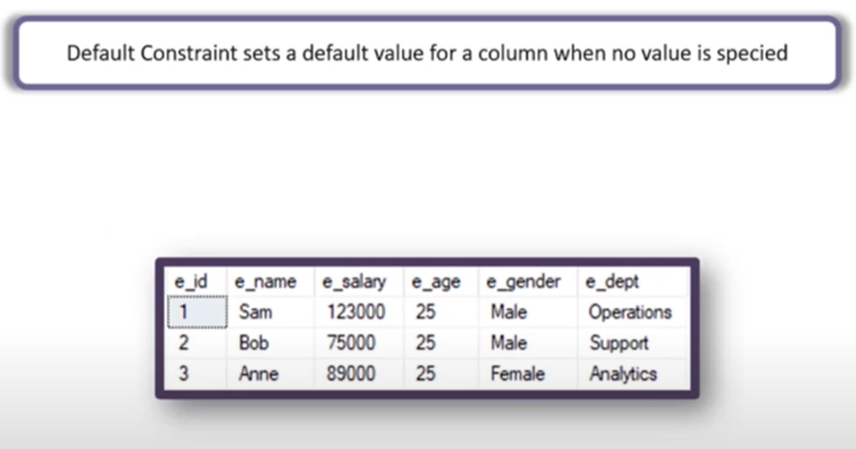

Syntax -
While creating a table

Run -
CREATE TABLE studentsinfo
(
studentid NUMBER,
studentname VARCHAR2(1000),
dob DATE,
country VARCHAR2(1000) DEFAULT 'india'
);
INSERT INTO studentsInfo (StudentId,StudentName,DOB)
VALUES (1,'Hari','09-05-2020');
INSERT INTO studentsInfo (StudentId,StudentName,DOB ,Country)
VALUES (2,'Amol','09-05-2020','USA');
INSERT INTO studentsInfo (StudentId,StudentName,DOB ,Country)
VALUES (3,'Raj','09-05-2020', null);

CREATE TABLE studentsinfo
(
studentid NUMBER,
studentname VARCHAR2(1000),
dob DATE DEFAULT sysdate,
country VARCHAR2(1000) DEFAULT 'india'
);

INSERT INTO studentsInfo (StudentId,StudentName)
VALUES (1,'Hari');
INSERT INTO studentsInfo (StudentId,StudentName,DOB )
VALUES (2,'Amol','09-05-2020');
Syntax -
After table created

Run -
CREATE TABLE studentsinfo
(
studentid NUMBER,
studentname VARCHAR(1000),
dob DATE,
country VARCHAR(1000)
);

ALTER TABLE studentsInfo MODIFY country DEFAULT 'INDIA';

INSERT INTO studentsInfo (StudentId ,StudentName,DOB )
VALUES (1,'Hari','09-05-2020');

INSERT INTO studentsInfo (StudentId,StudentName,DOB ,Country)
VALUES (2,'Amol','09-05-2020','USA');

Drop Default Constraint -

Syntax -
ALTER TABLE table_name DROP CONSTRAINT constraint_name;

Run -
ALTER TABLE studentsInfo MODIFY country DEFAULT NULL;
4. Check Constraint

- Check constraint is used to limit the range of the values that can be entered for a column.
- If we have a number AGE column in a table. The AGE in general cannot be less than ZERO and at the same time cannot be greater than 150. But, since AGE is a number column it can accept negative values and values much greater than 150.
- To limit the values that can be added we use Check constraint.
- Check constraint can be defined at column level as well as at table level.
- Check constraints can be added while creating a table or after the table is created.
- Check constraint allows null values while inserting records in table.

Syntax -
While creating a table

Run -
CREATE TABLE studentsinfo
(
studentid NUMBER,
studentname VARCHAR2(1000),
std_age NUMBER,
country VARCHAR2(1000)
);

INSERT INTO studentsInfo (StudentId, StudentName, std_age, Country)
VALUES (1,'Hari',-99,'INDIA');

INSERT INTO studentsInfo (StudentId, StudentName, std_age, Country)
VALUES (2,'Amol',200,'INDIA');

CREATE TABLE studentsinfo
(
studentid NUMBER,
studentname VARCHAR2(1000),
std_age NUMBER CHECK (std_age > 0 AND std_age < 150),
country VARCHAR2(1000)
);

INSERT INTO studentsInfo (StudentId, StudentName, std_age, Country)
VALUES (1,'Hari',25,'INDIA');

INSERT INTO studentsInfo (StudentId, StudentName, std_age, Country)
VALUES (2,'Raj',-99,'INDIA');

INSERT INTO studentsInfo (StudentId, StudentName, Country)
VALUES (3,'Amol','INDIA');

INSERT INTO studentsInfo (StudentId, StudentName, std_age, Country)
VALUES (4,'Ravi',151,'INDIA');

Syntax -
While creating a table (At Table level)

Run -
CREATE TABLE studentsinfo
(
studentid NUMBER,
studentname VARCHAR2(1000),
std_age NUMBER,
country VARCHAR2(1000),
CONSTRAINT check_std_age
CHECK (std_age > 0 AND std_age < 150 and studentid > 100)
);

INSERT INTO studentsInfo (StudentId, StudentName, std_age, Country)
VALUES (10,'Hari',25,'INDIA');

INSERT INTO studentsInfo (StudentId, StudentName, std_age, Country)
VALUES (151,'Raj',110,'INDIA');

Syntax -
After table created

Run -
CREATE TABLE studentsinfo
(
studentid NUMBER,
studentname VARCHAR2(1000),
std_age NUMBER,
country VARCHAR2(1000)
);

ALTER TABLE studentsInfo
ADD CONSTRAINT chk_std_age CHECK ( Std_age> 0 AND Std_age< 150 );

INSERT INTO studentsInfo (StudentId, StudentName, std_age, Country)
VALUES (1,'Hari', 25,'INDIA');

INSERT INTO studentsInfo (StudentId, StudentName, std_age, Country)
VALUES (2,'Raj',-99,'INDIA');

INSERT INTO studentsInfo (StudentId, StudentName, Country)
VALUES (3,'Amol','INDIA');

INSERT INTO studentsInfo (StudentId, StudentName, std_age, Country)
VALUES (4,'Ravi', 151,'INDIA');

Drop Check Constraint -

Syntax -
ALTER TABLE table_name DROP CONSTRAINT constraint_name;

Run -
ALTER TABLE studentsInfo DROP CONSTRAINT chk_std_age;

5. Primary Key Constraint

- Primary key is a column or a group of columns that uniquely identifies each row in a table.
- Primary key constraint can be defined at column level as well as at table level.
- Primary key constraint cannot allow null values.
- Each table can contain only one primary key.
- For two Primary key columns, Primary key constraints at table level can allow values in combination but at column level it should be unique.
- Can be applied while creating a table or after table is created.

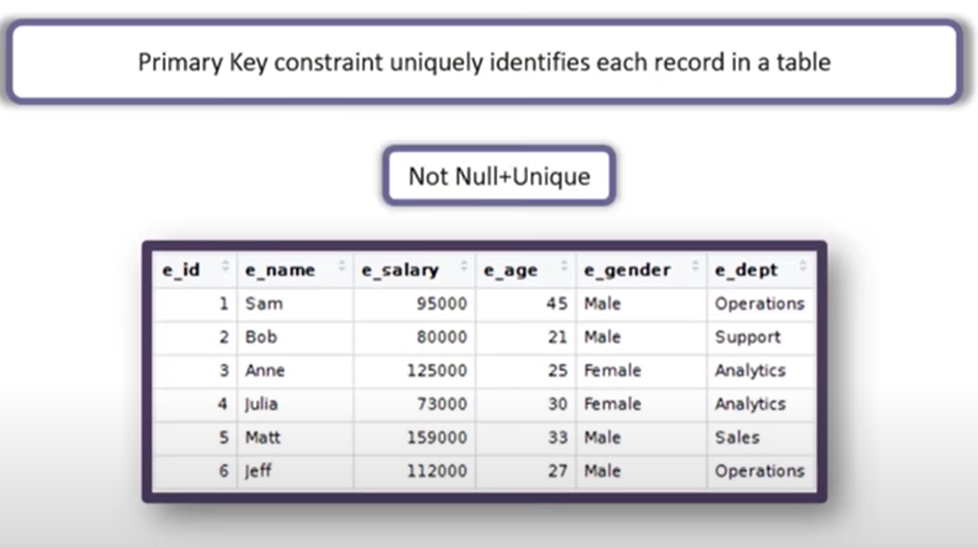

Syntax -
While creating a table (At column level)

Run -
CREATE TABLE studentsinfo
(
studentid NUMBER PRIMARY KEY,
studentname VARCHAR2(1000),
parentname VARCHAR2(1000),
phonenumber NUMBER
);

INSERT INTO studentsInfo (StudentId,StudentName,ParentName,PhoneNumber)
VALUES (1,'Hari','Prasad',78787878);

INSERT INTO studentsInfo (StudentId,StudentName,ParentName,PhoneNumber)
VALUES (1,'Amol','Prasad',78787878);

INSERT INTO studentsInfo (StudentId,StudentName,ParentName,PhoneNumber)
VALUES (null,'Hari','Prasad',78787878);

INSERT INTO studentsInfo (StudentName,ParentName,PhoneNumber)
VALUES ('Hari','Prasad',78787878);

Syntax -
While creating a table (At table level)

Run -
CREATE TABLE studentsInfo
(
StudentId NUMBER,
StudentName varchar(1000),
ParentName varchar2(1000),
PhoneNumber NUMBER,
PRIMARY KEY(StudentId, StudentName )
);

INSERT INTO studentsInfo (StudentId,StudentName,ParentName,PhoneNumber)
VALUES (1,'Hari','Prasad',78787878);

INSERT INTO studentsInfo (StudentId,StudentName,ParentName,PhoneNumber)
VALUES (1,'Amol','Prasad',78787878);

INSERT INTO studentsInfo (StudentId,StudentName,ParentName,PhoneNumber)
VALUES (null,'Hari','Prasad',78787878);

INSERT INTO studentsInfo (StudentName,ParentName,PhoneNumber)
VALUES ('Hari','Prasad',78787878);

Syntax -
After table created (At column level)

Run -
CREATE TABLE studentsInfo
(
StudentId NUMBER,
StudentName varchar2(1000),
ParentName varchar2(1000),
PhoneNumber NUMBER
);

ALTER TABLE studentsinfo ADD CONSTRAINT pk_studentid PRIMARY KEY(studentid);

INSERT INTO studentsInfo (StudentId,StudentName,ParentName,PhoneNumber)
VALUES (1,'Hari','Prasad',78787878);

INSERT INTO studentsInfo (StudentId,StudentName,ParentName,PhoneNumber)
VALUES (1,'Amol','Prasad',78787878);

INSERT INTO studentsInfo (StudentId,StudentName,ParentName,PhoneNumber)
VALUES (null,'Hari','Prasad',78787878);

INSERT INTO studentsInfo (StudentName,ParentName,PhoneNumber)
VALUES ('Hari','Prasad',78787878);

Syntax -
After table created (At table level)

Run -
CREATE TABLE studentsInfo
(
StudentId NUMBER,
StudentName varchar2(1000),
ParentName varchar2(1000),
PhoneNumber NUMBER
);

ALTER TABLE studentsInfo ADD CONSTRAINT PK_both PRIMARY KEY(StudentId, StudentName);

INSERT INTO studentsInfo (StudentId,StudentName,ParentName,PhoneNumber)
VALUES (1,'Hari','Prasad',78787878);

INSERT INTO studentsInfo (StudentId,StudentName,ParentName,PhoneNumber)
VALUES (1,'Amol','Prasad',78787878);

INSERT INTO studentsInfo (StudentId,StudentName,ParentName,PhoneNumber)
VALUES (null,'Hari','Prasad',78787878);

INSERT INTO studentsInfo (StudentName,ParentName,PhoneNumber)
VALUES ('Hari','Prasad',78787878);

Drop PK Constraint -

Syntax -
ALTER TABLE table_name DROP CONSTRAINT constraint_name;

Run -
ALTER TABLE studentsInfo DROP CONSTRAINT PK_both;

6. Foreign Key Constraint
- A Foreign Key is a key used to link two tables together.
- A Foreign Key is a column or a group of columns in one table that refers to the Primary key in another table or the same table in case of self-reference.
- The table containing the foreign key is called the child table, and the table containing the candidate key is called the referenced or parent table.
- Can be applied while creating a table or after table is created.
- The Foreign Key column cannot be applied on LOB, LONG, LONG RAW, VARRAY, NESTED TABLE, OBJECT, BFILE, REF and TIMESTAMP.
- A composite Foreign Key cannot have more than 32 columns.

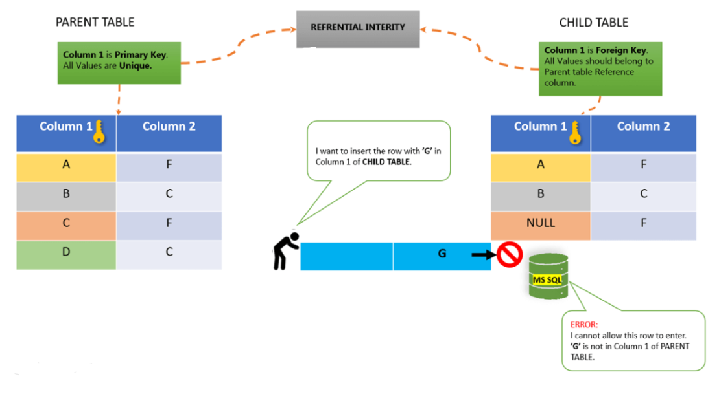
Syntax -
While creating a table -

Syntax -
CONSTRAINT fk_constraint_name
FOREIGN KEY (column_1, column2,...)
REFERENCES parent_table_name(column1,column2,..)

Run -
Parent Table -
CREATE TABLE vendor_groups
(
group_id NUMBER PRIMARY KEY,
group_name VARCHAR2(100) NOT NULL
);

Child Table -
CREATE TABLE vendors
( vendor_id NUMBER PRIMARY KEY,
vendor_name VARCHAR2(100) NOT NULL,
group_id NUMBER NOT NULL,
CONSTRAINT fk_group FOREIGN KEY (group_id)
REFERENCES vendor_groups (group_id)
);
- The vendor_groups table now is called the parent table that is the table to which the foreign key constraint references. The vendor table is called the child table that is the table on which the foreign key constraint is applied.
- In the vendor table we have creates a FOREIGN KEY constraint named fk_group that links the group_id in the vendors table to the group_id in the vendor_groups table

First, insert some rows into the vendor_groups table -

INSERT INTO vendor_groups(group_id, group_name)
VALUES (1, 'Third-Party Vendors');

INSERT INTO vendor_groups(group_id, group_name)
VALUES(2, 'Interco Vendors');

INSERT INTO vendor_groups(group_id, group_name)
VALUES(3, 'One-time Vendors');

Second, insert a new vendor with a vendor group into the vendors table -

INSERT INTO vendors(vendor_id,vendor_name,group_id)
VALUES(1,'ABC Corp',1);
Third, try to insert a new vendor whose vendor group does not exist in the vendor_groups table -
INSERT INTO vendors(vendor_id,vendor_name,group_id)
VALUES(2, 'XYZ Corp',4);
Referential Actions -

- The foreign key constraint ensures referential integrity. It means that you can only insert a row into the child table if there is a corresponding row in the parent table.
- Foreign key constraint allows you to define the referential actions when the row in the parent table is updated or deleted as follows:

Syntax -

FOREIGN KEY (foreign_key_columns)
REFERENCES parent_table(parent_key_columns)
ON UPDATE action
ON DELETE action;

Delete actions of rows in the parent table
If you delete one or more rows in the parent table, you can set one of the following actions:

ON DELETE CASCADE is used if a row in the parent table is deleted, then all the rows in the child table that reference to that row will be deleted.

ON DELETE SET NULL is used if a row in the parent table is deleted, then all the rows in the child table reference to that row will be set to NULL for the foreign key columns.

Example -

CREATE TABLE vendor_groups
(
group_id INT PRIMARY KEY,
group_name VARCHAR (100) NOT NULL
);

CREATE TABLE vendors
(
vendor_id INT PRIMARY KEY,
vendor_name VARCHAR(100) NOT NULL,
group_id INT NOT NULL,
CONSTRAINT fk_group FOREIGN KEY (group_id)
REFERENCES vendor_groups (group_id)
ON DELETE CASCADE
);

INSERT INTO vendor_groups(group_id, group_name)
VALUES (1, 'Third-Party Vendors'),
(2, 'Interco Vendors'),
(3, 'One-time Vendors');

INSERT INTO vendors(vendor_id, vendor_name, group_id)
VALUES(1,'ABC Corp',1);

DELETE FROM vendor_groups WHERE group_id = 1;

CREATE TABLE vendors
(
vendor_id INT PRIMARY KEY,
vendor_name VARCHAR(100) NOT NULL,
group_id INT NOT NULL,
CONSTRAINT fk_group FOREIGN KEY (group_id)
REFERENCES vendor_groups (group_id)
ON DELETE SET NULL
);

INSERT INTO vendor_groups(group_id, group_name)
VALUES (1, 'Third-Party Vendors'),
(2, 'Interco Vendors'),
(3, 'One-time Vendors');

INSERT INTO vendors(vendor_id, vendor_name, group_id)
VALUES(1,'ABC Corp',1);

DELETE FROM vendor_groups WHERE group_id = 1;

Syntax -
After table created -

ALTER TABLE child_table_name
ADD CONSTRAINT constraint_name
FOREIGN KEY (child_column_name)
REFERENCES parent_table (parent_column_name);

ALTER TABLE child_table_name
ADD CONSTRAINT constraint_name
FOREIGN KEY (child_column_name1, child_column_name2)
REFERENCES parent_table (parent_column_name1, parent_column_name2);

Run -
CREATE TABLE vendors
(
vendor_id INT PRIMARY KEY,
vendor_name VARCHAR(100) NOT NULL,
group_id INT NOT NULL
);

ALTER TABLE vendors
ADD CONSTRAINT FK_group_id
FOREIGN KEY (group_id)
REFERENCES vendor_groups (group_id);

Drop a Foreign Key Constraint -
Syntax -
ALTER TABLE table_name DROP CONSTRAINT fk_Constraint_name ;

Run -
ALTER TABLE vendors DROP CONSTRAINT FK_group_id;

Disable a Foreign Key Constraint -
Syntax -
ALTER TABLE table_name DISABLE CONSTRAINT fk_Constraint_name ;

Run -
ALTER TABLE vendors DISABLE CONSTRAINT FK_group_id;

Enable a Foreign Key Constraint -
Syntax -
ALTER TABLE table_name ENABLE CONSTRAINT fk_Constraint_name ;

Run -
ALTER TABLE vendors ENABLE CONSTRAINT FK_group_id;

To View All Constraint on table –

- Query USER_CONSTRAINTS table.
- The Codes that are revealed are
- P-Primary
- U-Unique
- R-References
- C-Check & Not Null

Example -
SELECT owner, constraint_name, constraint_type
FROM user_constraints
WHERE table_name = 'EMP';

To View Columns Associated with Constraint on table –

- Query USER_CONS_COLUMNS Date Dictionary View.

Example -
SELECT constraint_name, column_name
FROM user_cons_columns
WHERE table_name = 'EMP';

Note: When table is dropped all corresponding Integrity Constrains will dropped automatically.

__________________________THANK YOU____________________________

